# Testing and Evaluation

## Overview

This document contains details and screenshots of the testing and evaluation conducted for the Skin Disease Diagnosis web application. It highlights the functionality testing, model accuracy testing, and user interface testing to ensure a smooth and effective application.

## Functional Testing

## User Interface Testing

### 1. Browser Compatibility

1. **Objective**: Verify that the application works on multiple browsers.
2. **Browsers Tested**:
   1. Google Chrome
   2. Mozilla Firefox
   3. Brave
3. **Result**: The application is fully functional across all tested browsers.
4. **Screenshot**:

Chrome

Firefox

### 2. Responsive Design

1. **Objective**: Test the application's responsiveness on different devices.
2. **Devices Tested**:
   1. Desktop
3. **Result**: The application layout adjusts correctly for all screen sizes.

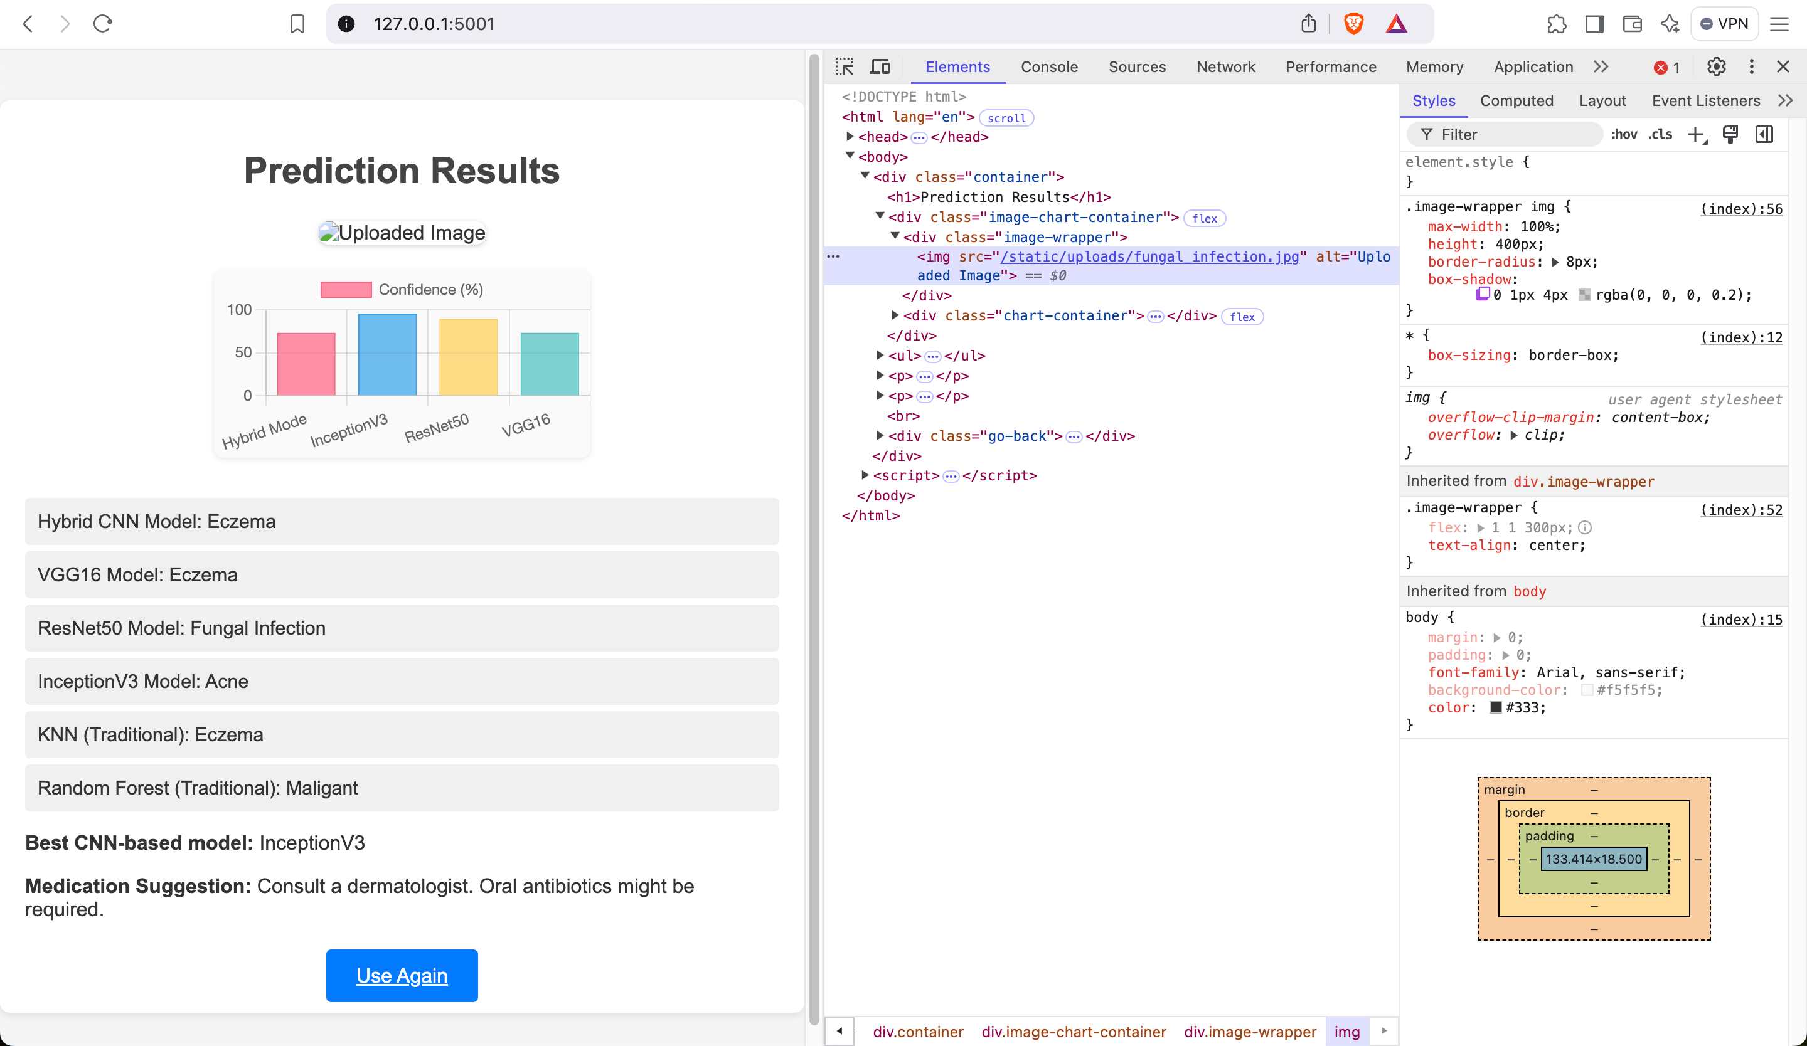

## Summary

### Key Findings:

* The application is stable and performs as expected under various scenarios.
* The CNN model demonstrates high accuracy for skin disease classification.
* The user interface is intuitive and responsive.